e-News Letter

ICAI BHAWAN, PLOT NO- A/122/1

NAYAPALLI, BHUBANESWAR – 751 012

THE INSTITUTE OF CHARTERED ACCOUNTANTS OF INDIA
(Set up by an Act of Parliament)
BHUBANESWAR BRANCH (EIRC)

MARCH & APRIL - 2020
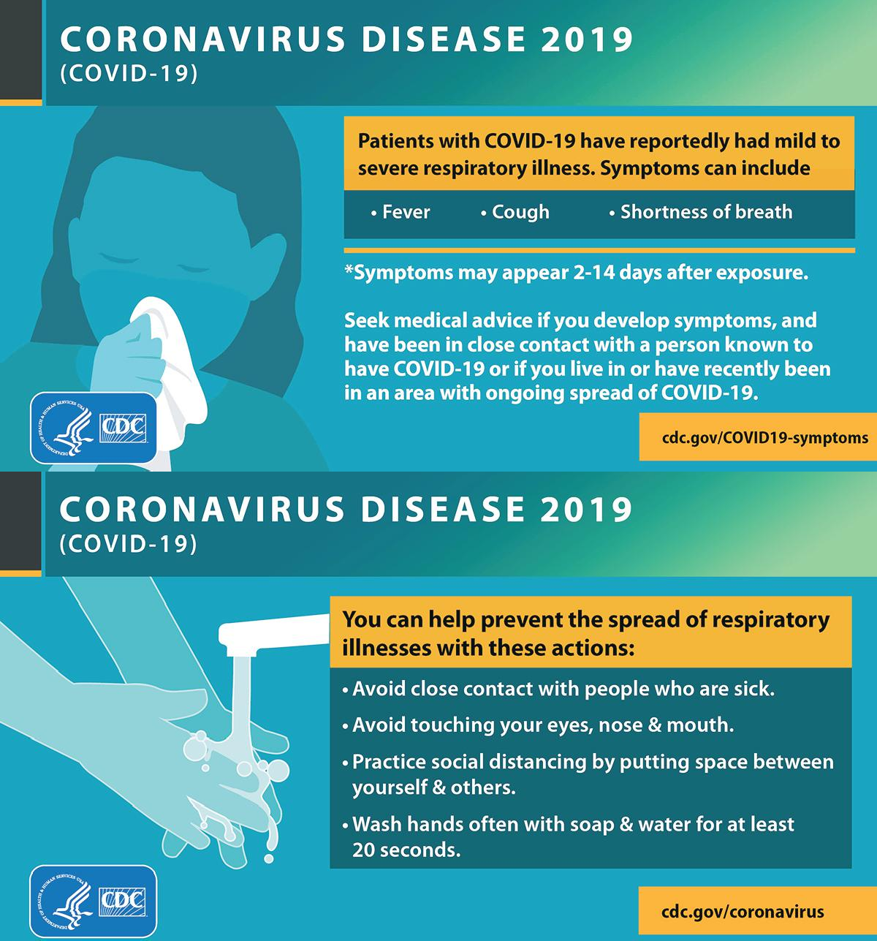
CONTENTS

ICAI 1
Corporate Laws 2
GST 3
Income Tax 4
5

From Chairman’s Desk

RELEASED BY:
CA. Bibhu Prasad Mohapatra
Chairman,
Bhubaneswar Branch of EIRC of ICAI
Plot No- A-122/1, Nayapalli,
Bhubaneswar - 751012

Phone: 91 674-2392391, 2390773

E-Mail: bhubaneswar@icai.org

Editorial Board

Editor-in-Chief:
CA Bibhu Prasad Mohapatra
Editors:
CA, CS Abinash Parida
Members:
CA BisworanjanSutar
CA Ranjan Kumar Prusty
CA Janhabi Deo
CA Pradip Kumar Sahoo
CA Goutam Lenka
CA Sugyan Kumar Sahoo
Disclaimer
Views expressed / advertisement published in the Newsletter are those of the contributors and do not necessarily represent the views of the Institute of Chartered Accountants of India and the Branch is not responsible for the same.
Dear Professional Colleagues,
Greetings
I express my gratitude to the esteemed members of Bhubaneswar Branch and Managing Committee Members for giving an opportunity to serve as 38th Chairman of Bhubaneswar Branch of EIRC of ICAI for the year 2020-21. It also gives immense pleasure to get connected with you all through March & April 2020 edition of member’s E-New Letter. I extent my thankfulness to my collegues in managing committee of Bhubaneswar Branch who have supported me to release this newsletter.

My vision is to create opportunities for my professional colleagues, take up initiatives of public interest and national growth, and support our Government as a true partner in nation building During this pandemic the physical offices are converting into virtual offices and work from home and using the IT platform to accomplish our task is the need of hour As all the physical activities are converting into a virtual activities the cyber security is the main threat and also the opportunities We all should try to convert most of our work in virtual mode and also use of good firewalls and other cyber security measure to keep safe the data of our office and also our clients.
Bhubaneswar Branch is also using the IT platform to connect our members and hosting series of webinars using video conferencing facilities This includes the interaction with members and other webinars on different dates in associations with EIRC, Cuttack, Rourkela, Sambalpur, Berhampur and Jharsuguda Branch. We will be planning to place more and more web based events at branch for benefits of members, students and public at large and turning those events into a brand building process in true spirits.
With this I conclude with a belief that many ideas grow better when transplanted into another mind than the one where they sprang up I sincerely expect the valuable contributions, suggestions and feedback to help me discharging my role as chairman for the year more effectively and efficiently.

Thank you!
With Warm Regards

CA. Bibhu Prasad Mohapatra
Chairman

MANAGING COMMITTEE MEMBERS
OF BHUBANESWAR BRANCH OF EIRC OF ICAI (2020-21)

CA. Bibhu Prasad Mohapatra
Chairman

``
CA. BisworanjanSutar
Vice Chairman

CA. Janhabi Deo
Treasurer

CA. Ranjan Kumar Prusty
Secretary

CA. Goutam Lenka
Member

CA. Pradip Kumar Sahoo
Chairman, EICASA, Bhubaneswar

CA. Sugyan Kumar Sahoo
Past Chairman & Member

ICAI

Date | Descriptions
06-03-2020 | ICAI Enters into An Arrangement for TP Corporate Database at a Concessional Rate.
04-03-2020 | Guidance Note on Audit of Banks 2020 edition
30-03-2020 | Extension of validity of Peer Review Certificate in the wake of COVID-19 spurt across the country.
20-03-2020 | Request for Information for comprehensive review of IFRS for SMEs Standard issued by the IASB for comments.
30-04-2020 | Discussion Paper Business Combinations-Disclosures, Goodwill and Impairment issued by the IASB for comments
28-04-2020 | Advisory on Mentioning Fees in Advertisements issued by Members
26-04-2020 | Exposure Draft on Covid-19-Related Rent Concessions (Proposed amendment to IFRS 16, Leases
21-04-2020 | Exposure Draft on Interest Rate Benchmark Reform-Phase 2 (Proposed amendments to IFRS 9, IAS 39, IFRS 7, IFRS 4 and IFRS 16)
16-04-2020 | ICAI invites suggestions/comments from members on Draft Valuers Bill, 2020 by 12.00 Noon on 10th May, 2020.
15-04-2020 | Advisory for Bank Branch Auditors
13-04-2020 | Use of Electronic Signature for Signing Audit Reports and Certificates -

INCOME TAX
NOTIFICATION NO. | DATE | HIGHLIGHTS
No. 2 OF 2020 | 31/03/2020 | Taxation and Other Laws Relaxation of Certain Provisions Ordinance, 2020
Bill No. 26-C of 2020 | 23/03/2020 | Download Finance Bill 2020 as passed by Lok Sabha
Notification No. 21/2020-Income Tax / S.O. 1195E. | 20/03/2020 | Corrigendum to Form-3 of Direct Tax Vivad se Vishwas Rules, 2020
Notification No. 20/2020- Income Tax | 20/03/2020 | AO working in Pr. CCIT International Taxation region is jurisdictional AO for equalisation levy
Notification No. S.O. 1188E | 20/03/2020 | Exemption to Mysore Palace Board- CBDT amends N/No. 33/2019
Notification No. 12 of 2020-DGITS | 19/03/2020 | Procedure for declaration & undertaking under Vivad se Vishwas Rules
F. No. Pr.CCITIntl. Tax/Delhi/VSV/Designated Authority/2019-20/4707 | 18/03/2020 | CBDT notifies ‘designated authority under ‘Direct Tax Vivad Se Vishwas Act, 2020
F.No. Pr.CCIT/Hqrs.Coord./Delhi/VSV/Designated Authority/2019-20/18641 | 18/03/2020 | Designated authority under Direct Tax Vivad Se Vishwas Act, 2020 in Delhi
Notification No. F.No. Pr. CCIT/ Lko/ Judi./VSV/Vol.2I/ 2019-20 | 18/03/2020 | Designated authority under Direct Tax Vivad Se Vishwas Act, 2020 in UP
Notification No. 18/2020-Income Tax/S.O. 1129E | 18/03/2020 | Direct Tax Vivad Se Vishwas Rules 2020
No:-P-11/12/Misc./SST Misuse/2019-Rev. II | 18/03/2020 | One-time Relaxation to Employers- ESI contribution- April 19 to Sep 19
NO. 3 OF 2020 | 17/03/2020 | President Assents Direct Tax Vivad se Vishwas Act, 2020
Notification No. 17-2020-Income Tax- S.O. 1057E | 13/03/2020 | Notification No. 17/2020-Income Tax, Dated: 13.03.2020
Notification No. 16/2020-Income Tax [S.O. 986E] | 05/03/2020 | CBDT notifies Transactions not regarded as transfer U/s. 47viiabd
Notification No. 15/2020-Income Tax [G.S.R. 159E] | 05/03/2020 | CBDT amends Rule 17C to include investment made by NPCI in its subsidiary companies
Notification No. 14/2020 [S.O. 1009E.] | 04/03/2020 | CBDT notifies DTAA with Brunei Darussalam
Bill No. 29-C of 2020 | 04/03/2020 | Direct Tax Vivad Se Vishwas Bill, 2020 passed by Lok Sabha
Notification No. 22/2020-Income Tax /F.No. 505/01/1982-FTD-I (Pt.) [S.O. 1370(E).] | 24/04/2020 | CBDT notifies Protocol Between India And Austria
CORRIGENDA to Finance Act 2020- No. 12 of 2020 | 15/04/2020 | Corrigenda to Finance Act, 2020

GST (GOODS & SERVICES TAX)

NOTIFICATION NO. | DATE | HIGHLIGHTS
Circular No. 135/05/2020-GST | 31/03/2020 | CBIC Clarification on GST refund related issues
No VAT-1520/CR-34/Taxation-1 and No VAT-1520/CR-35/Taxation-1 | 30/03/2020 | Change in VAT rate on petrol & diesel in Maharashtra WEF 01.04.2020
Notification No. 03/2020-Central Tax (Rate) | 25/03/2020 | CBIC revises GST rate of matchsticks & telephone sets
Notification No. 02/2020–Central Tax (Rate) [G.S.R. 1209(E).] | 25/03/2020 | GST reduced to 5% on MRO services of aircraft with full ITC
Notification No. 02/2020–Integrated Tax [G.S.R. 1212(E).] | 25/03/2020 | Place of supply for B2B MRO services to be location of recipient: CBIC
Notification No. 03/2020-Union territory Tax (Rate) [G.S.R. 218(E)] | 25/03/2020 | CBIC revises UTGST rate of Matchsticks & Telephone Sets
Notification No. 03/2020-Union Territory Tax (Rate) [G.S.R. 1211(E).] | 25/03/2020 | UTGST reduced to 5% on MRO services of aircraft with full ITC
Notification No. 03/2020-Intergrated Tax (Rate) [G.S.R. 217(E).] | 25/03/2020 | CBIC revises IGST rate of Matchsticks & Telephone Sets
Notification No. 02/2020–Integrated Tax (Rate) [G.S.R. 1210(E).] | 25/03/2020 | IGST reduced to 5% on MRO services of aircraft with full ITC
Notification No. 11/2020- Central Tax dated 21.03.2020 |  | New GST Compliance for registered corporate debtor under CIRP
Notification No. 29/2020–Central Tax | 23/03/2020 | CBIC notifies GSTR-3B with due dates for April 2020 to September 2020
Notification No. 28/2020-Central Tax [G.S.R. 211(E)] | 23/03/2020 | Due date of monthly GSTR-1 for first 6 Months of Year 2020-21
Notification No. 27/2020-Central Tax [G.S.R. 210(E)] | 23/03/2020 | Due date of quarterly GSTR-1 for first 2 quarters of Year 2020-21
Notification No. 26/2020-Central Tax [G.S.R. 209(E)] | 23/03/2020 | Due date of Monthly GSTR-3B (July 19 – Sep 19) extended for erstwhile J&K State
Notification No. 25/2020-Central Tax [G.S.R. 208(E)] | 23/03/2020 | Due date of Monthly GSTR-3B (Oct 19 – Feb 20) extended for erstwhile J&K State
Notification No. 24/2020-Central Tax [G.S.R. 207(E)] | 23/03/2020 | Due date of Sep-19 QtrGSTR-1 extended for erstwhile J&K State
Notification No. 23/2020–Central Tax | 23/03/2020 | Due date of Monthly GSTR-1 (July 19 to Sep 19) extended for erstwhile J&K State
Notification No. 22/2020-Central Tax [G.S.R. 205(E)] | 23/03/2020 | Due date of Monthly GSTR-1 (Oct 19 to Feb 20) extended for erstwhile J&K State
Notification No. 21/2020-Central Tax [G.S.R. 204(E)] | 23/03/2020 | Due date to furnish Dec-19 Quarter GSTR-1 extended for erstwhile State of J&K
Notification No. 20/2020-Central Tax [G.S.R. 203(E)] | 23/03/2020 | Due date for furnishing GSTR-7 extended for erstwhile State of J&K
Notification No. 19/2020–Central Tax [G.S.R. 202(E)] | 23/03/2020 | Persons other than individuals who must do Aadhaar authentication for GST Registration
Notification No. 18/2020-Central Tax [G.S.R. 201(E)] | 23/03/2020 | Aadhaar number authentication must for GST registration wef 01.04.2020
Notification No. 17/2020-Central Tax [G.S.R. 200(E).] | 23/03/2020 | CBIC specifies class of persons exempt from aadhar authentication
No. F.12(46)FD/Tax/2017-PtN-146 | 23/03/2020 | Reimbursement of SGST to hotels and tour operators in Rajasthan
Notification No. 16/2020-Central Tax [G.S.R. 199(E).] | 23/03/2020 | Central Goods and Services Tax (Third Amendment) Rules, 2020
Notification No. 15/2020-Central Tax [G.S.R. 198(E)] | 23/03/2020 |  | GSTR-9 &GSTR-9C due date extended to 30.06.2020 for FY 2018-19
Circular No. 134/04/2020-GST | 23/03/2020 |  | Clarification on issues under GST for companies under IBC, 2016
Circular No.133/03/2020-GST | 23/03/2020 |  | Apportionment of ITC in cases of business reorganization
Notification No. 14/2020–Central Tax [G.S.R. 197(E)] | 21/03/2020 |  | Deferment of implementation date of QR Code
Notification No. 13/2020–Central Tax [G.S.R. 196(E)] | 21/03/2020 |  | GST E-Invoice exemption & Deferment of implementation date notified
Notification No. 12/2020–Central Tax [G.S.R. 195(E)] | 21/03/2020 |  | Exemption from filing CMP-08 / GSTR-1 if filed GSTR-3B for FY 2019-20
Notification No. 11/2020–Central Tax [G.S.R. 194(E)] | 21/03/2020 |  | Special GST procedure for corporate debtors undergoing insolvency resolution process
Notification No. No. 10/2020–Central Tax [G.S.R. 193(E)] | 21/03/2020 |  | Special procedure for Merged UTs of Daman & Diu & Dadra & Nagar Haveli
Internal Circular No. 4A of 2020. | 20/03/2020 |  | Time barring assessment under Maharashtra VAT Act- Internal Instructions
N/A |  |  | Request for not increasing Threshold Limit for GST Annual Return & Audit
Trade Circular No. 05 T of 2020 | 19/03/2020 |  | SOP to be followed by exporters- GST Refund
Trade Circular No. 04T of 2020 | 19/03/2020 |  | No Late Fees on PT Return for periods up to March 2019 in Maharashtra
Notification No. S.O. 1123(E) | 18/03/2020 |  | Jammu and Kashmir Reorganisation (Adaptation of Central Laws) Order, 2020
Circular No. 132/2/2020 - GST | 18/03/2020 |  | GST Appeal in regard to non-constitution of Appellate Tribunal
Trade Circular No. 03T of 2020. | 17/03/2020 |  | MGST-Corona Virus- Avoid Physical Visits at dealers place
D.O.No.06/CH(IC)/2020 | 16/03/2020 |  | Issue Polite reminders for filing of GSTR-3B- CBIC Chairman
Notification No. 09/2020– Central Tax [G.S.R. 179 (E)] | 16/03/2020 |  | Govt exempts foreign airlines from furnishing Form GSTR-9C
Press Release ID: 1606433 | 14/03/2020 |  | Recommendations of 39th GST Council Meeting on IT Roadmap
Press Release ID: 1606432 | 14/03/2020 |  | Changes in GST rates on goods & services in 39th GST Council Meeting
Press Release ID: 1606430 | 14/03/2020 |  | 39th GST Council recommendations on Law & Procedures
Press Release ID: 1606416 | 14/03/2020 |  | Need to bring aviation turbine fuel under GST: Hardeep Singh Puri
NA | 13/03/2020 |  | No sitting of benches of CESTAT this week, except urgent hearings, due to Corona Virus
Circular No. 123/42/2019– GST | 11/03/2020 |  | Relevant date of which GSTR-2A is used to calculate Restriction on ITC of 10%
Notification No. 08/2020-Central Tax [G.S.R. 147(E).] | 02/03/2020 |  | Govt notifies value of supply of lottery for GST
No. 331-F.T. | 02/03/2020 |  | Govt amends West Bengal Sales Tax (Settlement of Dispute) Rules, 1999
Trade Circular No. 6T of 2020 | 30/04/2020 |  | Maharashtra PT: Waiver from Late Return Filing Fees
Notification No. 37/2020–Central Tax [G.S.R. 266(E)] | 28/04/2020 |  | CBIC notifies effective date for Rule 87(13) & Form GST PMT09
Notification No. 7/2020-State Tax | 28/04/2020 |  | Kerala Flood Cess Return filing dates extended for Feb 20 to May 20
D.O.No.12/CH(IC)/2020 | 27/04/2020 |  | DGGI founds case of Non-payment of IGST on free-of-cost import of software
Notification No. D.O.No.11/CH(IC)/2020 | 20/04/2020 |  | GSTN enabled work from home possible for GST Staff
Circular No. 137/07/2020-GST | 13/04/2020 |  | Challenges in implementation of GST provisions – CBIC clarifies
D.O.No. 10/CH(IC)/2020 | 13/04/2020 |  | CBIC issues ITC refund under GST of Rs. 2800 crore in 10 days
Instruction No. 2/1/2020-GST | 09/04/2020 |  | Implementation of decision to expedite pending GST refund claims
Notification No. 1/2020–Union Territory Tax | 08/04/2020 |  | UTGST: Conditional for lowering of interest rate for GSTR3B notified
Notification No. 3/2020 – Integrated Tax | 08/04/2020 |  | CBIC notifies conditional lowering of interest rate for GSTR3B
D.O.No. 09/CH(IC)/2020 | 06/04/2020 |  | GST Covid-19 relief package, 7 GST notification Issued
Notification No. 36/2020-Central Tax [G.S.R. 236(E)] | 03/04/2020 |  | CBIC extends due date for furnishing GSTR-3B for May 2020 Month
Notification No. 35/2020-Central Tax [G.S.R. 235(E)] | 03/04/2020 |  | CBIC extends Due date of GST compliance & validity of e-way bills
Notification No. 34/2020-Central Tax [G.S.R. 234(E)] | 03/04/2020 |  | Due date to furnish CMP-08 &GSTR-4 extended for March Quarter
Notification No. 33/2020-Central Tax [G.S.R. 233(E)] | 03/04/2020 |  | Conditional waiver of late fee for delay in furnishing FORM GSTR-1
Notification No. 32/2020-Central Tax [G.S.R. 232(E)] | 03/04/2020 |  | Conditional waiver of late fee for delay in furnishing FORM GSTR-3B
Notification No. 31/2020-Central Tax [G.S.R. 231(E)] | 03/04/2020 |  | Lower GST interest Rate only on timely filing of FORM GSTR-3B
Notification No. 30/2020-Central Tax [G.S.R. 230(E)] | 03/04/2020 |  | GST Composition Scheme for FY 2020-21 can be opted till 30.06.2020
Circular No. 136/06/2020-GST | 03/04/2020 |  | CBIC Clarifies GST Return due date extension and related issues

Company Law
NOTIFICATION NO. | DATE | HIGHLIGHTS
General Circular No. 13/2020 | 30/03/2020 | MCA modifies LLP Settlement Scheme 2020
General Circular No. 12/2020 | 30/03/2020 | Companies Fresh Start Scheme, 2020
NA | 30/03/2020 | MCA introduces Companies Fresh Start Scheme 2020 & Revises LLP Settlement Scheme 2020
weF. No. CSR-05/1/2020-CSR-MCA | 28/03/2020 | Contribution to PM CARES Fund shall qualify as CSR expenditure
General Circular No. 11/2020 | 24/03/2020 | COVID-19 – Special relief Measures for Companies & LLP
S.O. 1219E | 24/03/2020 | MCA defers applicability of CARO 2020 to 1st April 2020 FY 2020-21
General Circular No. 10/2020 | 23/03/2020 | Spending of CSR funds for COVID-19 is eligible CSR activity: MCA
D.O. No. SecyMCA/COVID-19/1/2020 | 19/03/2020 | Web form CAR- Board meetings with physical presence of directors relaxed -MCA
Notification No. G.S.R. 186 E. | 19/03/2020 | Companies Meetings of Board and its Powers Amendment Rules, 2020
Bill No. 88 of 2020 | 17/03/2020 | Govt introduces Companies Amendment Bill, 2020 in Lok Sabha
Notification No. S.O. 1060E | 13/03/2020 | Constitution of NCLAT Bench at Chennai
Notification No. G.S.R...E | 13/03/2020 | Draft Companies CSR Policy Amendment Rules, 2020 for comments
General Circular No. 09/2020 | 12/03/2020 | Last date to file MGT-7 and AOC-4 in J&K& Ladakh extended to 30.06.2020
Notification No. G.S.R. 169E | 12/03/2020 | Companies Incorporation second Amendment Rules, 2020
Notification No. G.S.R. 170E | 12/03/2020 | Companies Registration Offices and Fees Second Amendment Rules, 2020
General Circular No. 08/2020 | 06/03/2020 | Filing of forms in Registry MCA-21 by IRP or RP or Liquidator- MCA clarifies
Notification No. F. No. Legal-35/3/2020 | 06/03/2020 | Committee to prepare Investigation manual for SFIO
General Circular No. 07/2020 | 05/03/2020 | MCA Extend last date of filing of Form NFRA-2 for FY 2018-19
Notification No. G.S.R.151E | 02/03/2020 | New Exemptions to Government Companies | Companies Act 2013
General Circular No. 1/2020 | 02/03/2020 | MCA clarifies on prosecutions for defaults committed by a company
General Circular No. 19/2020 | 30/04/2020 | Last date of filing of Form NFRA-2 extended to 210 days from deployment date
G.S.R. 268 (E) | 29/04/2020 | Companies (Appointment and Qualification of Directors) Second Amendment Rules, 2020
Notification No. NF-20011/3/2020 | 28/04/2020 | Draft Procedure for Submission of Audit Files to NFRA
General Circular No. 18/2020 | 21/04/2020 | Companies allowed to hold AGM till 30.09.2020 whose FY ending on 31.12.2019
General Circular No 17/2020 / Press Relase ID No. 1614099 | 13/04/2020 | MCA further clarifies on passing of ordinary & special resolutions- COVID-19
General Circular No. 16/2020 | 13/04/2020 | MCA allows filing of IEFF e-forms till 30.09.2020 without additional fees
General Circular No. 15/2020 | 10/04/2020 | COVID-19 related FAQs on Corporate Social Responsibility by MCA
General Circular No. 14/2020 | 08/04/2020 | MCA allows companies to hold EGMs through VC or OAVM

